Clap Switch Circuit Electronic Project Using 555 Timer & BC-547 Transistors

Introduction to Clap Switch Circuit
Clap Switch is a basic electronics mini-project, made with the help of the basic components. Clap Switch has the ability to turn ON/OFF any electrical component or circuit by the clap sound. We will use two basic clap switch circuit diagrams i.e. (With IC 555 Timers and without 555 Timer).
It is known as Clap Switch because the condenser mic which will be used in this project will have an ability to take the sound having the same pitch as the clap sound as the input. Although it doesn’t mean that the sound will have to be exactlt the clap sound, it can be any sound having the same high pitch as clapping sound. We can also say that it converts the sound energy into the electrical energy because we are giving an input to the circuit as a sound whereas the circuit gives us the output as an LED light when glows (electrical energy). In more simple words, the circuit is able to convert the sound energy to activate the circuit and led provide electrical energy as an output in the form of heat and light.
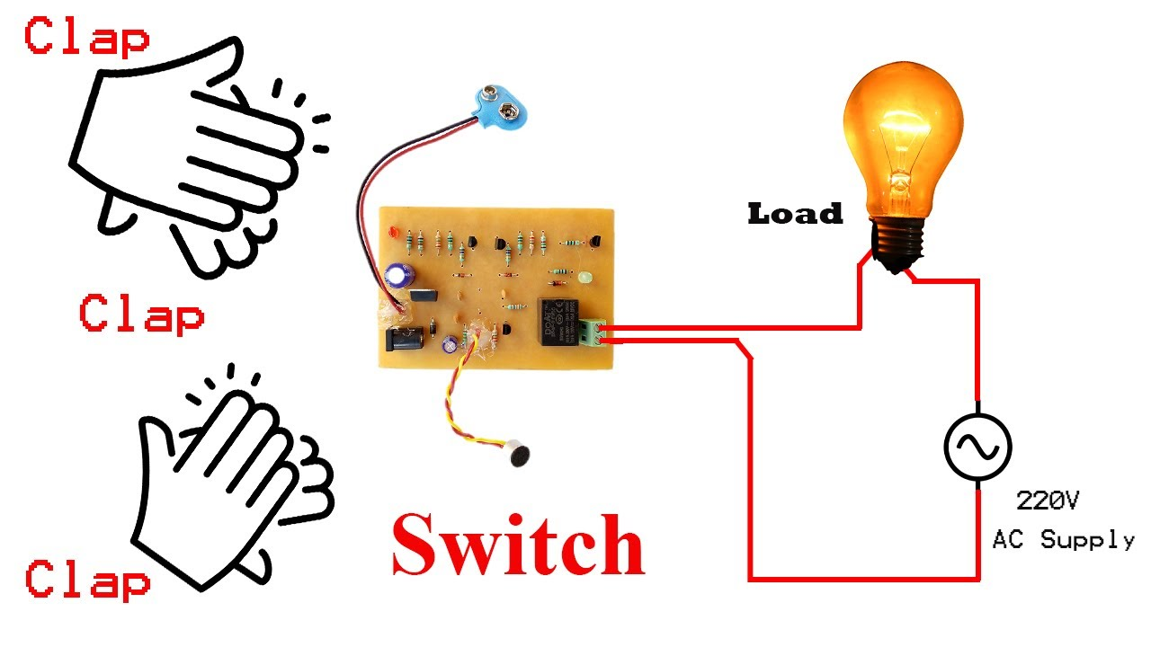
Required Components
As already mentioned, this project is basic electronics mini-project, so this project is made of the basic electronic components.
Following is the list of the components required to make the Clap Switch.
- 1k, 4.7k, 47k, 330 and 470 ohms resistors
- 10µF(microfarad) and 2 100nF capacitors
- Electric condenser Mic
- Two BC547 transistors
- LED
- 555 Timer
- 9V battery

Working Principle of Clap Switch Circuit
This circuit (As shown below) is made with the help of Sound activated sensor, which senses the sound of Clap as input and processes it to the circuit in order to give the Output. When sound is given as the input to the Electric Condenser Mic, it is changed into the Electrical Energy as the LED turns on. LED turns ON, as we give sound input and it turns OFF automatically after a few seconds. Turn-On LED timer can be changed by varying the value of 100mF capacitor as it is connected with 555 timer whose main purpose is to generate the pulse.
Although the name of the circuit is the Clap Switch, you are not restricted to give input as the Clap only. It can be any sound, having the same pitch as of Clap so this can also be called as “Sound Operated Switch”. This circuit is mainly based on transistors because the negative terminal of Mic is directly connected with the transistor. In this circuit, we haven’t used any Electronic Switch to turn on/off the circuit, so when you are connecting the battery with the circuit, it means your circuit is now turned ON and it will take the inputs in the form of Sound Energy. You can modify this circuit by using Relay as Electronic Switch to turn the circuit ON or OFF.
As soon as we give the sound input to the circuit, it amplifies the sound signals and proceeds them to the 555 timer which generates the pulse to the LED, making it turn ON. You are to make sure, that the negative side of the Condenser mic is connected with the amplifier or the circuit will heat-up and may not work with different models of transistors etc. You cannot increase the sensitivity of the Condenser mic for long usage, it has a short range by default. It is also applicable to the LAMP and fans and other electrical appliances, so this circuit has many opportunities for modification.

